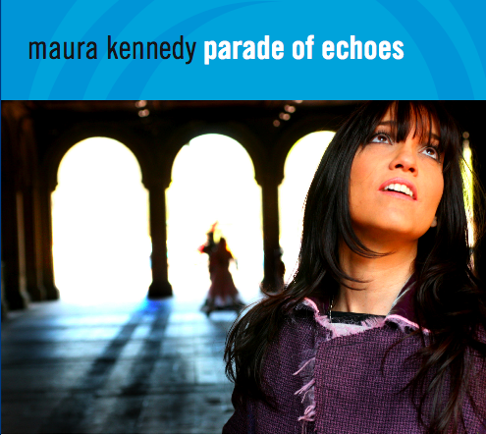
MAURA KENNEDY
PARADE OF ECHOES

Powerful Pop For Serious People
(release date: January 5, 2010)

The daughter of a professor of English, and the ”musical one” of seven children (others include a nuclear physicist, a comedian, a photographer, and a couple of authors), Maura Kennedy carved out her moments of teenage creative solitude sequestered in a closet, blasting Queen and Kate Bush on headphones, while she read C.S. Lewis and Stephen R. Donaldson. Not given to the hermitic life, she made nocturnal escapes, crawling out of her bedroom window and across the roof of her family’s suburban split-level home, to hit the streets of post-industrial Syracuse, New York, in search of crunching power chords and soaring pop hooks.

She found them—and was always the first on the dance floor—in small clubs where R.E.M. and Squeeze were scrounging gas money for the road, and especially at a dusty used record shop, where she got a job just to spin vinyl all day. She soaked up the Kinks, the Hollies, the Raspberries, and leavened the sweetness with a strong dose of Thompson/Denny era Fairport Convention. In the stainless steel splendor of the Little Gem Diner, the Ramones autographed her Social Security Card. At college, she pawned her meal tickets to buy an amp and lived off of her bandmate’s doggie bags. She cracked a couple of ribs in the mosh pit at a Clash show and finally got the music degree. After spending the night in an upstate Greyhound station when she missed the last bus following a Cheap Trick concert, she and some like-minded friends formed a combo and blazed a trail through the Syracuse club scene. And with the breeze off Onondaga Lake at her back, she took off for Austin.

It was in Austin that she made her bones, and it was there that her stage persona came together: always rocking, always “in the zone,” and always full-on energy. It was also in Austin that she hooked up with Nanci Griffith, and toured the US and the British Isles behind Nanci’s Grammy-winning Other Voices, Other Rooms. Working the road in the acoustic format of roots-pop mavens The Kennedys, her songwriting blossomed, as she began drawing from novels, poetry, and especially from her own dreams.

From Largo in L.A. to the Borderline in London, it’s always come back to pop music, with an ever-maturing darker underlay, and for Maura, the road has always led back to New York City. She’s lived in a number of tenements around St. Mark’s Place, many of them hastily converted into makeshift recording studios, and it was in that neighborhood that she conceived the idea of writing a song, and making a master-quality recording, every month for thirteen months. The resultant compilation would be a sort of melodic journal of her emotional seasons. While keeping up a busy schedule of shows and acting gigs, she finished the project in the autumn of 2009.

PARADE OF ECHOES delivers on the power chords and the hooks, but it’s no concoction of pop cotton candy. You may hear traces of her love of Brill Building sheen, but lyrically, Maura doesn’t shrink from the heavy stuff; she deals with depression and obsession, and she doesn’t pray for divine intervention. Shadowy dreamscapes evoke Emily Dickinson, the ’50’s noir of Patsy Cline, and even Shakespeare’s cursed Thane of Cawdor, by way of Don and Phil Everly. “The Thing with Feathers” is dark, almost Gothic in the Victorian sense, but it ultimately powers its way through the shadow to a kind of dark hope, stronger for its admissions of weakness and doubt. “New Way to Live,” like “Some Kind of Life,” expresses a shared secret wish, the longing we all feel sometimes for what might have been, with a chorus that rolls in and out like the surf at Rockaway Beach. “Sun Burns Gold” and “October” play like intimate diary entries. “Chains” and “Just the Rain” deal with love as an uncontrollable force, drawing their pulsating energy from that deep well of power.

It’s been said that a good songwriter comforts the disturbed, and disturbs the comfortable. Maura, having mastered the craft, does both in a thirteen-song soliloquy by simply having the strength to stand strong in the face of life. Where the songs deal with emotional thunderclouds, she confronts them head on, just as she once drove straight into a line of crackling desert storm cells out on the Arizona border. The best part is, it’s all cast in the sheen of her carillon harmonies and bell-like vocal tone.

Maura is fond of quoting Joseph Campbell on the role of an artist—to break windows through the walls of culture to eternity. With PARADE OF ECHOES, on which she not only sings, but plays most of the instruments and produces and engineers, she breaks down walls, and the result is a masterwork that will inspire and empower a legion of listeners—and maybe get them on their feet to dance, too.

www.MauraKennedy.com

